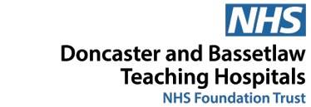

Speech and Language Therapy
Tier 3
Specialist intervention

What we expect from you:
- To provide Universal and Targeted support and interventions
- To complete referral form and communication checklist
- At the initial assessment session, the child’s teacher and the member of staff carrying out the speech and language therapy programme to be available for discussion.
- A named member of staff in school who will carry out speech and language therapy programme with the child or young person
- This member of staff to be available for all sessions with Speech and Language Therapist (S&LT)
- To provide a quiet, distraction-free room for all sessions

What we will provide:
- Comprehensive initial assessment in school for children in year 1 and above with language difficulties
- Intervention in school for children whose language difficulties are having a detrimental impact on their academic and social attainment.
- Time and opportunities to liaise with school staff
- Time for coaching staff members working with children, via video or face to face
- If appropriate, some children will receive more regular sessions in school with a S&LT assistant
- Ongoing development of our service in line with evidence based practice

